Preparation of phenol from the following process is commonly known as:
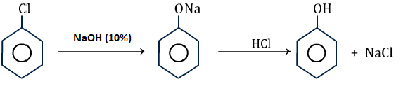
A. Down’s process
B. Nelson cell
C. Sepik’s process
D. Ostwald process
ANSWER: A

On heating aqueous solution of benzene diazonium chloride, which of the following is formed?
A. benzene
B. chlorobenzene
C. phenol
D. aniline
ANSWER: C

Sodium benzene sulphonate reacts with NaOH and then on acidic hydrolysis, it gives which of the following compound?
A. Phenol
B. Benzoic acid
C. Benzene
D. Disodium benzaldehyde
ANSWER: A

Reaction of aqueous sodium hydroxide on chlorobenzene gives which of the following products?
A. o-chlorophenol
B. o-chlorophenol
C. phenol
D. no reaction
ANSWER: C

What will be the product ‘a’ for the given reaction?
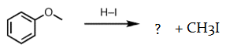
a)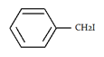
B. 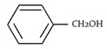
C. 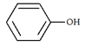
D. 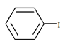
ANSWER: C

The product B in the below reaction is:
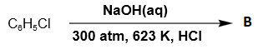
A. Phenol
B. Benzol
C. Sodium benzoate
D. Benzal
ANSWER: A

What is the reagent which will react with cumene to give phenol?
A. Oxygen
B. Hydrogen
C. Nitrogen
D. Ozone
ANSWER: A
Which of the following is not a method for preparation of phenol?
A. Dows process
B. From diazonium salt
C. By decarboxylation of salicylic acid
D. By the decarboxylation of sodium benzoate
ANSWER: D
A in the reaction below is:
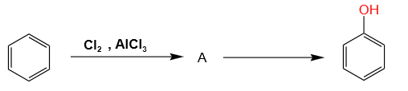
A. Chlorobenzene
B. 1,2-Dichlorobenzene
C. 1,3 –Dichlorobenzene
D. None of these
ANSWER: A
Phenol is obtained by heating aqueous solution of which of the following?
A. Aniline
B. Benzene diazonium chloride
C. Benzoic acid
D. Benzyl alcohol
ANSWER: B
Which of the following is known as base hydrolysis of Chlorobenzene?
A. Down’s process
B. Nelson cell
C. Sepik’s process
D. Ostwald process
ANSWER: A
Which of the following reaction produce acetone with phenol?
A. Down’s process
B. Acidic Oxidation of Cumene
C. Hydrolysis of Benzene diazonium chloride
D. Benzene sulphonic acid with Sodium hydroxide
ANSWER: B
What will be the product ‘a’ in the given reation?
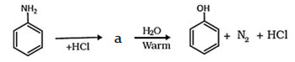
The product ‘a’ in the given reation is Benzene diazonium chloride
A. Enolate form
B. Benzene diazonium chloride
C. Benzene
D. Chlorobenzene
ANSWER: B
What is the reactant ‘x’ and ‘y’ that will react with benzene to give phenol?
A. X is Oleum and y is molten sodium hydroxide followed by H+
B. X is Oleum and y is HCl
C. X is Oleum and y is NH3
D. X is Oleum and y is water
ANSWER: A
Phenol is also known as:
A. Formalin
B. Naphthalene
C. Carbolic acid
D. Cresol
ANSWER: C

